Page 1 - Important information for school visits to all Festivals
Page 3 - Additional information for school visits to Cheltenham Literature Festival

WHAT CAN WE DO TO PLAN AND PREPARE FOR OUR VISIT?
- Arrange your travel to arrive a minimum of 30 minutes before the scheduled start of your first event.
- Prepare a risk assessment using our Risk Assessment Advice available on our website.
- Teachers/adults accompanying pupils should run through expectations regarding appropriate behaviour and consideration for other audience members and Festival-goers.

WHERE DO WE GET OFF THE COACH?
- The designated drop-off point for all Festivals is on the west side (Promenade) of Imperial Gardens (see map below). The nearest postcode for this is GL50 1PZ.
- Car parking will be suspended on this side of Imperial Square, adjacent to the Holst fountain. Your coach should pull in, facing South (up the hill in the direction of Montpellier Gardens), so that you can disembark safely. Coaches will not be able to stop on the other side of the road. Please ensure that your coach driver is aware of this.
- Coaches must leave the drop-off point swiftly.

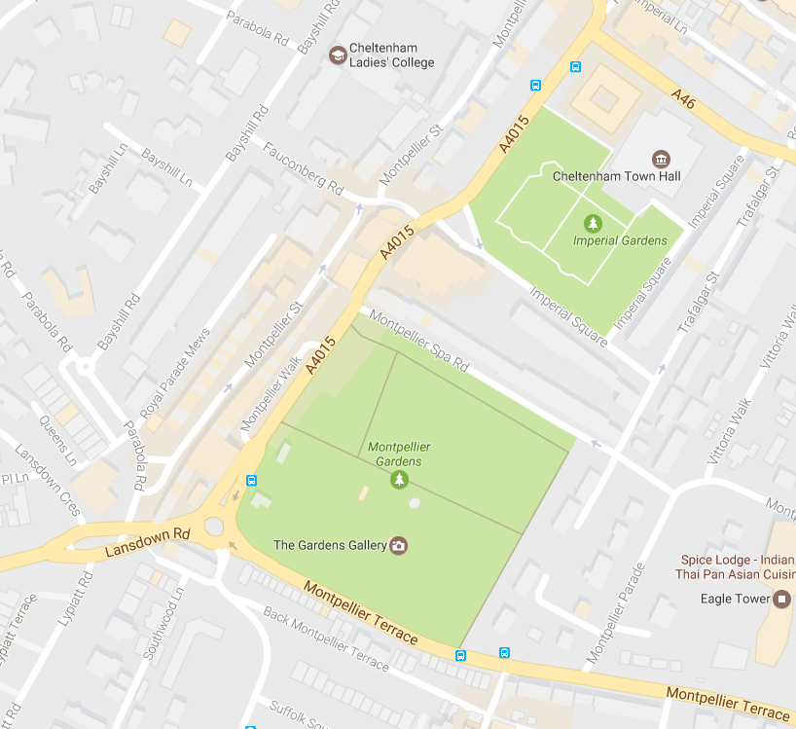
Coach drop-off point for schools for all Festivals
WE ARE TRAVELLING BY MINIBUS, WHERE CAN WE PARK?
- If travelling by minibus, you may either find a parking place and then report to us at the Promenade, or drop off your pupils with a member of staff and then find a parking place. There are car parks nearby on Rodney Road and Bath Parade.

HOW WILL WE KNOW WHERE TO GO?
- Festival staff and volunteers wearing orange high visibility jackets will be waiting for you. They will meet and greet you at the drop-off point, escort you safely to your first venue, and will be on hand to deal with queries and provide assistance throughout your visit.
- If you will be arriving on foot, please come to the drop off point so we can check you in and let you know of any last-minute venue changes.

WHERE CAN WE EAT LUNCH?
- There is plenty of space to picnic in the Imperial Gardens or Montpellier Gardens. If you wish to reserve space in our covered picnic area (available for Science and Literature Festivals only), please include this request on your booking form and we will do our best to accommodate you.

WHAT IF THE WEATHER’S BAD?
- Please make sure your party are appropriately dressed for the weather. Although almost all events take place inside, access to the venues often means waiting outdoors before events.

WHAT FACILITIES ARE AVAILABLE IN THE FESTIVAL VILLAGE?
- Qualified first aiders will be on duty in the Festival Village.
- Toilets are located in the Festival Village.
- You will be sent a map of the Festival Village with your ticket document a few weeks before your visit, which will identify all facilities available.
- Festival staff and volunteers will be on hand to deal with queries and provide assistance throughout your visit. If you require specific assistance, please let us know in advance.

DURING THE EVENTS
- Supervision of pupils/children whilst waiting to access the venue, during intervals, and on exiting the venue is the responsibility of the accompanying teachers/adults.
- If a child in your party needs to leave a venue for any reason, a responsible adult must accompany them. Please ensure the rest of your group is adequately supervised as Cheltenham Festivals does not act in loco parentis.
- All mobile phones must be switched off.
- On occasion, technical preparations force us to delay access to a venue. We endeavour to keep waiting to a minimum. We would appreciate your understanding should this happen to you.

PHOTOGRAPHY AND FILMING
- Official Cheltenham Festivals’ photographers and film crews may be present at school events to capture engagement. They will always ask your permission and will not name individuals, although schools may be named. We use this material for marketing both during and after events and to demonstrate impact in reports, on our website, and in brochures.

Additional information for all school visits to Cheltenham Literature Festival:

CAN WE MEET THE AUTHOR AND HAVE BOOKS SIGNED?
- Yes, and we encourage it! Authors love meeting young readers.
- After your event, the author will be waiting for you in the Waterstones Children’s Book Tent.

WHAT ELSE CAN WE DO TO PLAN AND PREPARE FOR OUR VISIT?
- Read books by the author(s) you are going to see.
- Find out about the author(s) you are going to see.
- Think of a question to ask the author(s) during the Q and A section of your event, or when you meet the author in the Waterstones Children’s Book Tent after your event.
- Bring your books with you if you would like them signed, or bring money if you would like to buy a book.

